Stem cell therapy: is the US missing a trick?
Written by Honor Whiteman Last updated: Thu 25 February 2016

When this article was first published on February 24th, we received criticism that it was promoting the World Stem Cells Clinic. Medical News Today always aim to provide balanced, reliable news; although the original article provided information on both sides of this clearly heated issue, we have updated the article with further research to make it clear that there are cases for and against using current stem cell therapies for conditions such as autism.

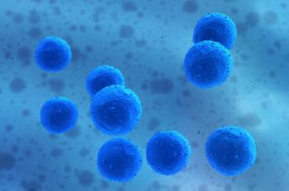
Most stem cell therapies are not approved in the US, causing many Americans to travel abroad for treatment.
Autism, cerebral palsy, multiple sclerosis: they are all incurable diseases. But there is one treatment that may offer hope to patients with such conditions - autologous stem cell transplantation. In the US, however, this procedure is only used to treat patients with blood-forming disorders, meaning many Americans are traveling far and wide to countries where it is approved for their condition.
One such place is World Stem Cells Clinic in Cancun, Mexico, where Americans and Canadians account for around 70-75% of all patients treated.
The clinic offers autologous stem cell transplantation for the treatment of numerous conditions, including autism, systemic lupuserythematosus (SLE), chronic obstructive pulmonary disease (COPD) and multiple sclerosis (MS).
Autologous stem cell transplantation uses the patient's own stem cells, which are cells that are capable of developing into many other types.
In autologous stem cell transplantation, the cells are harvested from the patient's own blood or bone marrow and are re-introduced at a later date. The treatment aims to kick-start the immune system, ridding the body of harmful cells.
Dr. Ernesto Gutiérrez, president and medical director of the World Stem Cells Clinic, spoke to MNT about the results his clinic has seen with autologous stem cell transplantation - particularly for autism - and discussed whether Americans are missing out on this treatment as a result of FDA regulations.

Autism: 'patients have improved after stem cell therapy'
Dr. Gutiérrez says autism is by far the most common condition treated at World Stem Cells Clinic. This is likely to come as no surprise; rates of autism have risen rapidly in recent years, increasing by 6-15% annually in the US alone between 2002-2010, and treatment options for the condition are limited.
Autism is a developmental disorder characterized by social impairment, communication difficulties and learning and behavioral problems. It currently affects around 1 in 68 children in the US, primarily boys.
At present, there are no treatments that can help tackle the core symptoms of autism; current behavioral and communication therapies - such as speech or occupational therapy - and medications may help children with autism to function better.
But according to Dr. Gutiérrez, the stem cell treatment provided by World Stem Cells Clinic has "consistently" led to improvements for children with autism.
The autism stem cell treatment the clinic provides spans over 5 days, costing around $17,000. The price includes accommodation and transportation for the patient and their family members throughout their entire stay.

How does the treatment work?
Explaining how the treatment works, Dr. Gutiérrez told us: "We harvest the stem cells, then we infuse them into the CNS [central nervous system] via lumbar puncture and IV [intravenous], and we address different areas that are expected in patients with autism. We also provide early stimulation, which allows us to kick start brain plasticity again."
Dr. Gutiérrez is keen to stress that each and every patient is closely monitored after treatment.
"We don't just provide treatment and send them on their way and never hear from them. We stay in touch, we like to work with their physicians whenever they want to get involved, and we promote patients to start doing a lot of activities; it is very important to start challenging these kids neurologically."
Patient outcomes after treatment are measured with an objective test that draws on information provided by the child's parents and other individuals who are in contact with the patient.
Common outcomes seen after treatment include overall improvements in behavior, improved eye contact and attention span, better communication and improvements in concentration and social interaction.
According to Dr. Gutiérrez, the treatment has been such a success that it has received a great deal of interest from the autism community, which may help to expand the treatment elsewhere:
"A lot of parents are very happy they're coming, we're increasing our numbers and we're working together with different organizations and clients within the autism industry, because our goal is to generate even more data, gather more information and make this available so it can be offered in different areas."

Other stem cell treatment successes...and failures
It is not only patients with autism that may benefit from autologous stem cell transplantation, says Dr. Gutiérrez.
He told MNT that patients with COPD - a progressive lung disease - have seen success after stem cell therapy at his clinic, with patients seeing improvements in chest tightness, breathing, wheezing and overall quality of life.
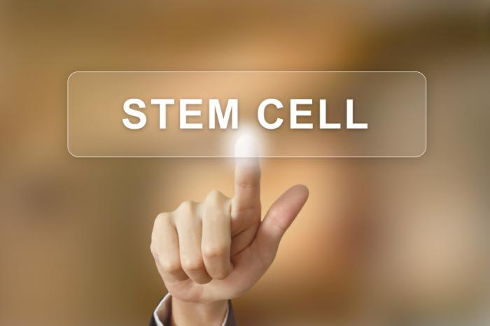
Dr. Gutiérrez said he has seen a 90-95% success rate with stem cell therapy for patients with COPD.
He noted that stem cell treatment is more successful for some conditions than others, however.
"Through our process, we have had some complications - for instance, with MS - where patients have not improved as much as expected, and in those cases, that's where there may be a second treatment - if we thought that would make a difference. If we thought that it wouldn't make a difference, then there's no point in treating them again."
And while some studies have suggested that stem cell therapy may be effective for the treatment of amyotrophic lateral sclerosis(ALS), also known as Lou Gehrig's disease, Dr. Gutiérrez says the type of treatment they offer is ineffective against the condition.
"ALS makes absolutely no sense to treat with the stem cell treatment that we provide; patients with the condition don't really see any improvement," he told us.
He pointed out that because the clinic's selection criteria is so stringent, however, they do not witness treatment failures very often. "We're not just going to accept patients who are just good on paper. [...] we need to make sure that there is a significant chance of improvement - we don't want to just gamble."

Why is this treatment not available in the US?
In Mexico, the treatment provided at the World Stem Cells Clinic is based on clinical research and protocols that have been approved by the country's Ministry of Health. In the US, however, it is very different.
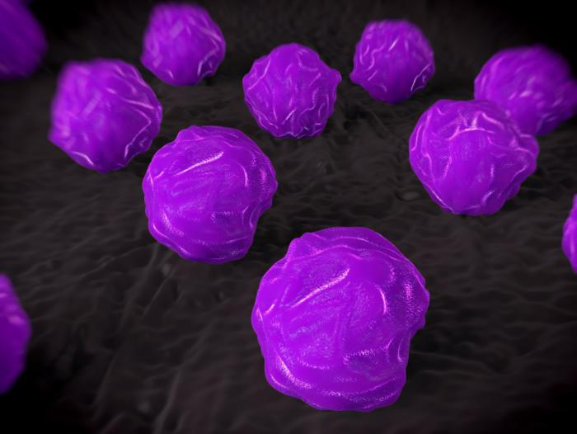
In the US, stem cell therapy is assessed in the same way as drugs.
The US Food and Drug Administration (FDA) have only approved one stem cell treatment - Hemacord - for the treatment of disorders affecting the body's blood-forming system, such as leukemia,lymphoma and sickle cell anemia.
But when it comes to conditions such as autism, COPD and MS, the FDA say there is insufficient clinical evidence to date to conclude that stem cell therapy is a safe and effective treatment option, though the procedure continues to be trialed for such diseases.
The FDA assess the safety and efficacy of stem cell therapy in the same way they assess the safety and efficacy of drugs. In a health policy report published in The New England Journal of Medicine in 2006, the FDA stated:
"Any stem-cell-based product that contains cells or tissues that 'are highly processed, are used for other than their normal function, are combined with non-tissue components, or are used for metabolic purposes' - and that includes most, if not all, of them - would also be subject to the Public Health Safety Act, Section 351, which regulates the licensing of biologic products and requires the submission of an investigational new drug application to the FDA before studies involving humans are initiated."

FDA 'using an outdated structure to trial a new technology'
Critics of the FDA, however, state that stem cell therapies - particularly autologous stem cell therapy - should not be put through the same testing procedure as drugs.
"The FDA's position against someone using their own stem cells is taking it too far. We are talking about a person using their own tissue to treat a degenerative disorder or process safely without the use of medications or surgery," Dr. Frank Falco, a member of the American Stem Cell Therapy Association (ASCTA), commented in 2009.
"Although we agree that oversight and standards are necessary," he added, "this should be provided through a physician organization such as ASCTA rather than by a government agency."
Dr. Gutiérrez agreed that the FDA's testing process in relation to stem cell therapy is not ideal:
"They have a process and each process tests the safety and efficacy for a pharmaceutical product. They want to use that same test and that same structure to approve the effectiveness and safety of cellular products - that simply doesn't make sense, the measuring stick is not equivalent and the treatments are not equivalent.
They're simply using an outdated structure to trial a new technology which is simply a completely different game."
Still, Dr. Gutiérrez told us that the World Stem Cells Clinic and other organizations across the globe are working with the FDA in order to push forward stem cell therapy approval in the US, but he pointed out that it is likely to be another 5-10 years before Americans can access the treatment on home turf.

Research into stem cells and autism
Autism spectrum disorders (ASDs) are a complicated web to untangle, and the medical community is not entirely sure of the root cause. Several theories have been put forward, including a link between antidepressant use during pregnancy and a possible immune response to viral infection during pregnancy.
However, one growing link to autism has involved immune dysregulation. As such, researchers have proposed stem cell therapies for use in ASDs. Because certain stem cells have immunological properties that make them ideal for regenerative medicine, researchers have suggested they could be used in diseases with inflammation and tissue damage.
In a 2014 study, published in the World Journal of Stem Cells, researchers write that stem cells "could exert a positive effect in ASDs through the following mechanisms: stimulation of repair in the damaged tissue, e.g. inflammatory bowel disease; synthesizing and releasing anti-inflammatory cytokines and survival-promoting growth factors; integrating into existing neural and synaptic network, and restoring plasticity."
They add:
"The paracrine mechanisms of MSCs [mesenchymal stem cells] show interesting potential in ASD treatment. Promising and impressive results have been reported from the few clinical studies published to date, although the exact mechanisms of action of MSCs in ASDs to restore functions are still largely unknown."
They conclude their study by noting that although ASDs are still untreatable, "stem cells possess the immunological properties which make them promising candidates as a novel therapeutic option."
The key words here, of course, are "promising candidates." There still remains more research to be done, at least from the eyes of the FDA.

Watch out for unscrupulous stem cell clinics
Until such therapies are available in the US, it is likely that many patients will continue to travel to countries like Mexico in the hope of receiving stem cell therapy that could potentially change their lives.
But this does present problems. Worldwide, there are many unscrupulous stem cell clinics looking to take advantage of vulnerable patients, offering them treatments that are unsuitable for their condition and that could potentially cause harm.
There are many unscrupulous stem cell clinics that are willing to take advantage of patients' vulnerability.
"It is something that we have been very aware of that is happening all over the world," Dr. Gutiérrez told MNT.
"Most of the time, when patients need medical care and their health care system says 'we don't have anything available for you,' they just don't take no for an answer. Unfortunately, that is also the situation in which patients are very vulnerable. Someone could just come over and sell them snake oil and in the best case, it won't work, but in the worst case scenario, it could really endanger them."
So, what should patients look out for when it comes to choosing a stem cell clinic for their treatment?
"If the clinic doesn't have a vigorous selection process, meaning that if the only criteria that you need in order to be accepted is to have enough money to pay for the treatment, that is definitely a red flag," Dr. Gutiérrez warned.
"If it is not being conducted by physicians, that is also a red flag - just like I wouldn't go to an MP to get acupuncture, I don't expect to go to a homeopath and let them harvest my stem cells," he added.
Dr. Gutiérrez said that any stem cell clinic that boasts claims based on patient testimonials rather than scientific literature should also be avoided, as should clinics that do not have a physician or a team of doctors willing to talk to patients about their treatment; patient-doctor communication is of key importance.

